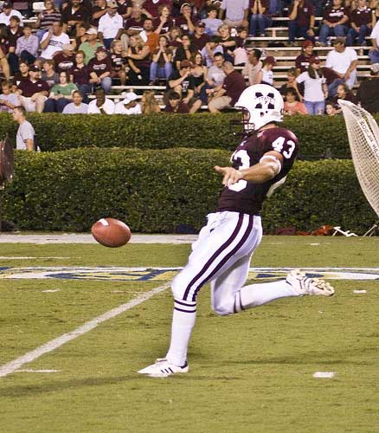

Punter punting

<http://www.secsportsfan.com/images/college-football-punt.jpg>